GSA 18F Proposal CloudWatch Monitoring Screen Shots:

Summary of Alarms for Test and Production Server CPU Utilization and Auto Scale Groups in AWS:

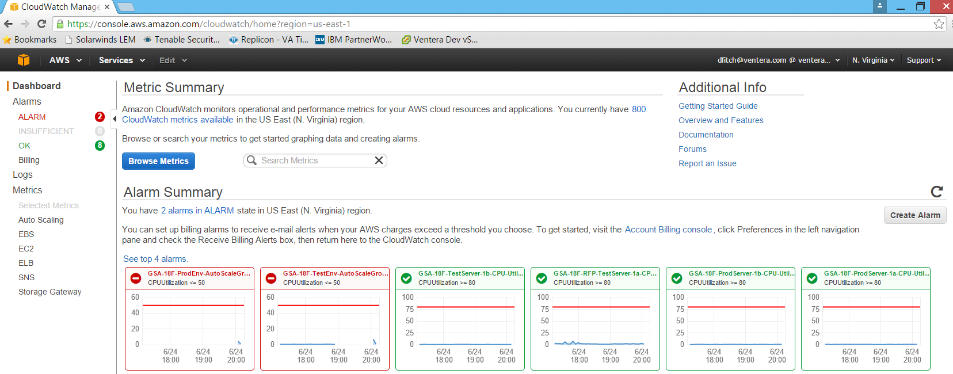

Details of Alarm for Production Environment Server CPU Utilization:

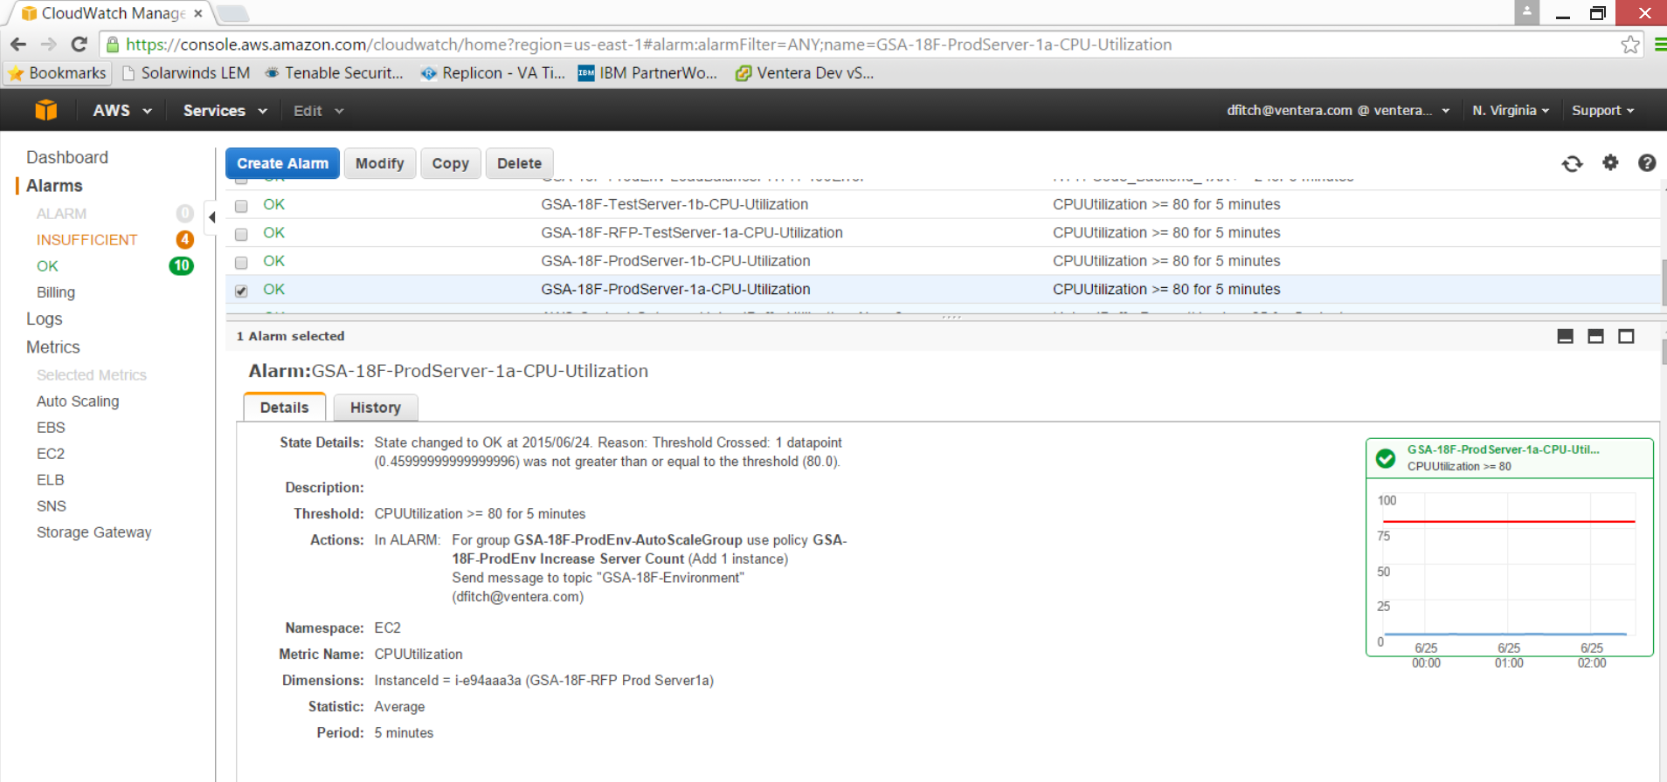

History of Alarm for Production Server CPU Utilization:

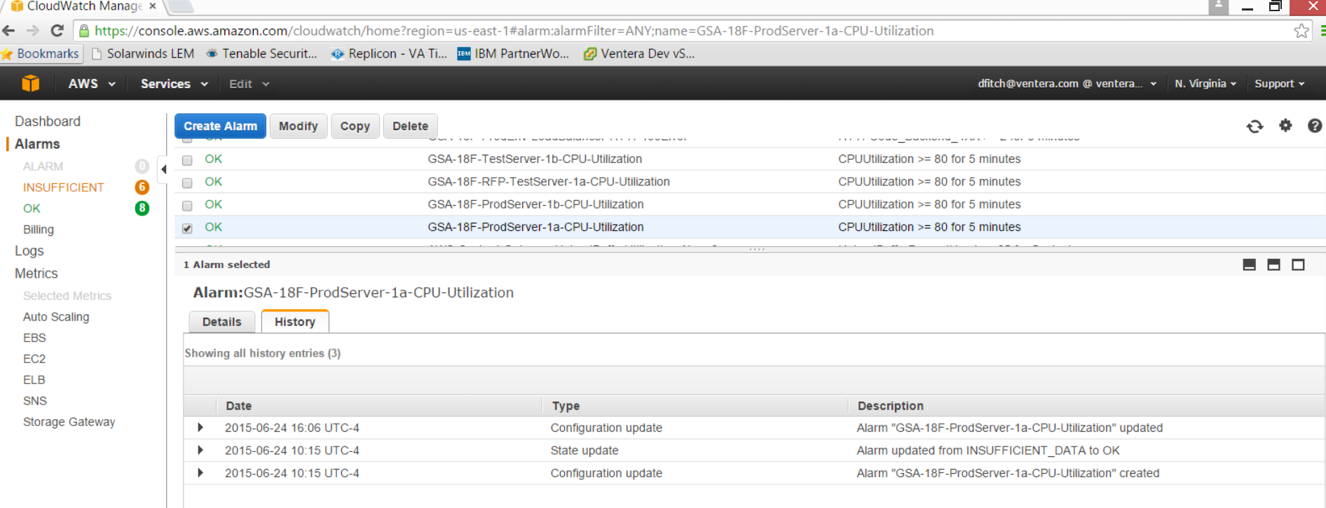

Monitoring and Details of Alarm for Production Environment Load Balancer Request Count:

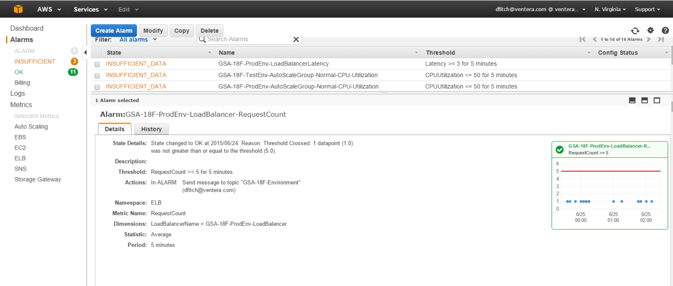

Details of Alarm for Production Environment Load Balancer HTTP 4XX Error Codes:

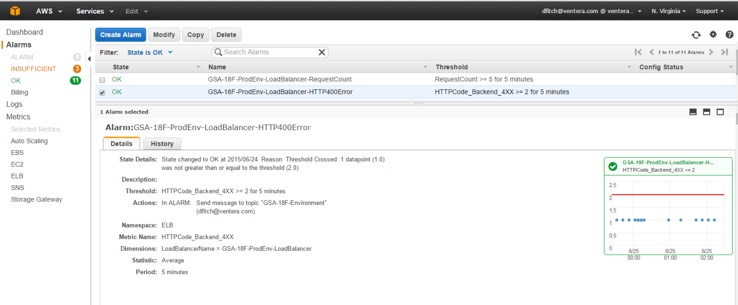

History of Alarm for Production Environment Load Balancer HTTP 4XX Error Codes:

